Question 1 (1 point)
What is the default gateway?
A number assigned to the hard drive of the local LAN.
A number assigned to the switch interface with the local LAN.
A number assigned to the router interface with the local LAN.
A number assigned to the mother of a PC on the local LAN.
Question 2 (1 point)
Running the command to find out what IP address has been assigned to your network adapter reveals an IP address of 169.254.10.22. Can you conclude that your network adaptor has successfully acquired an address from the DHCP server?
No, that is not an IP address for the DHCP server
Yes, this IP address comes from the DHCP server
Maybe, yes, maybe no
Computers don't have an IP address at all
Question 3 (1 point)
When you were doing lab 2, you used the red port to connect to a remote router. What was the default gateway IP address for that remote router?
192.168.1.1
172.16.255.254
10.10.10.254
169.16.1.254
Question 4 (1 point)
You have just finished configuring the IP address on your workstation. Your gateway address is 172.16.255.254. What command would you enter to test that the gateway is reachable?
Ipconfig 172.16.255.254
Tracer 172.16.255.254
Test 172.16.255.254
Ping 172.16.255.254
Question 5 (1 point)
In lab 2, what command did you use to find the default gateway address?
Ipconfig
Ping
Tracert
router
Question 6 options: (1 point)
Which of the following commands did you use to get this page?
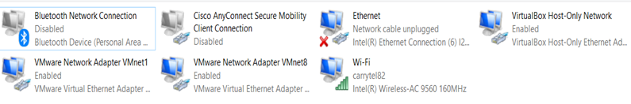
Ipconfig
Ncpa.cpl
Ethernet page
NIC page

